

|  |
| --- |
|  |
| System Design Document  **Indoor Climate Control System** |
| |  |  |  | | --- | --- | --- | | Group #3 | 14-April-2022 | T2-CB01 Project | |

* Authors :
  + Victor Covalciuc
  + Farros Ramzy
  + Andy Verkooijen
  + Sonam Lama

Table of Contents

Document history 2

Terms, Abbreviations 2

1. Introduction 3

1.1. Project description 3

2. System description 3

3. System Design 4

3.1. Main features 4

3.2. System Context 4

3.3. System Hardware Modules 4

3.4. Subsystems 5

3.4.1. Controller 5

3.4.2. Communication Protocol 5

3.4.3. more … 5

3.4.4. Ventilation 5

3.5. State Machine 5

References 5

Appendix 5

List of Figures

Figure 1: an example of a “system context” diagram, replace your diagram here 4

Figure 1: an example of a “system hardware modules” diagram, replace your diagram here 4

Figure 2: an example of a “state machine” diagram, replace your own diagram here 5

List of Tables

**No table of figures entries found.**

# Document history

|  |  |  |  |  |  |
| --- | --- | --- | --- | --- | --- |
| **Version** | **Date** | **Status** | **Author** | **Description** | **Remarks** |
| 1.0.0 | 14-04-2022 | Scarp | All Auth. | * Creation on template * Cover Page * Insertion of Diagrams * Insertion of read-written paragraphs * Sketch writing of missing paragraphs | W.I.P. |
| 1.1.0 | 15-05-2022 | Draft | Victor Covalciuc |  | W.I.P. |
| 2.0.0 | 15-05-2022 | Final | Victor Covalciuc |  |  |
|  |  |  |  |  |  |
|  |  |  |  |  |  |

* ­­ Highlighted in green is the current version on which the document is on.

# Terms, Abbreviations

|  |  |
| --- | --- |
| Term | Enlarged Version of said Term |
| SDD | System Design Document |
|  |  |

# Introduction

This document contains only parts of the system design. The design of other parts and aspects of the system should be made and documented accordingly in this document. (introduction on Airios and her products)

Describe what the team is going to build (comfort home project)….

## Project description

Write down what you are going to building

# System description

High level description of the system the team is going to build.

**Main functionalities:**

In addition to the primary function of the system, the secondary function is to allow an easier operation whenever user has needs for it. For this purpose, xxx can:

* **Show the energy usages of every room**:
* **troubleshooting**: it can detect issues and maintenance jobs whenever needed and notify the user instantly via the app

# System Design

# Main features

In this section the system main features/functionalities are described.

# System Context

System context diagrams show a system, as a whole and its **inputs** and **outputs** from/to external factors. See [link](https://en.wikipedia.org/wiki/System_context_diagram).

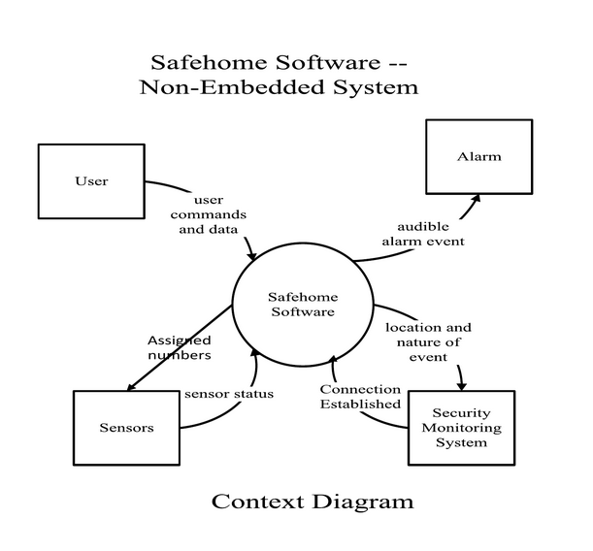

Figure 1: an example of a “system context” diagram, replace your diagram here

# System Hardware Modules

This section will describe all hardware blocks, important pin connection in the system.

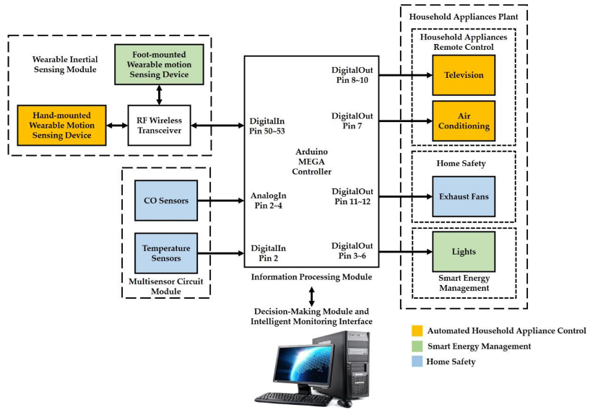

Figure 2: an example of a “system hardware modules” diagram, replace your diagram here

# Subsystems

Main blocks (software) of the system. The subsystems exchange information with each other, which is indicated as a received message or sent message. Messages can contain parameters that carry the data that are exchanged between different subsystems.

# Controller

In this section, the algorithms will be described.

# Communication Protocol

# more …

# Ventilation

Simulation, how the ventilation box will be simulated?

# State Machine

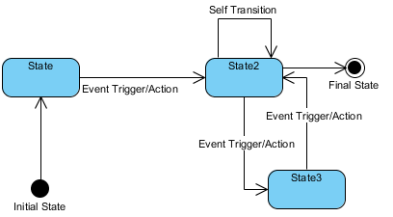

Figure 3: an example of a “state machine” diagram, replace your own diagram here

# References

# Appendix